SOUPS





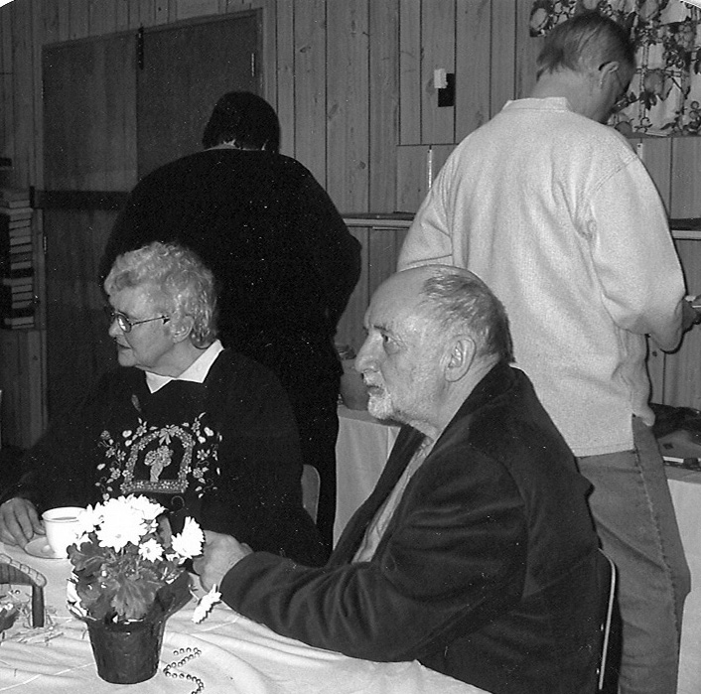

Borscht

water to cover potatoes and beets
2 whole beets (peeled)
1 whole large potato
4 medium carrots (grated)
1 large onion diced
2 tins diced tomatoes
1 medium cabbage (shredded)
1 small cauliflower (bite sized pieces)
2 tins green beans
2 green peppers (diced)
2 Tbsp. fresh dill weed (or to taste)
1 lb butter

To make beet stock

1. Put 4 Tbsp butter and water in pot. Add potato and peeled beets; cook until soft. Salt to taste. Mash potatoes and return to pot. Remove beets and discard. Add grated carrots.

2. Cook half the onion in 4 Tbsp butter until soft, but not browned. Add tomatoes and continue cooking for a few minutes. Add to stock.

3. In large frying pan, fry other half of onion in 4 Tbsp butter until soft. Add shredded cabbage to sweat, but do not brown. Add to beet stock.

4. Add last of butter to frying pan mixture and cook cauliflower, peppers and beans. Add fresh dill when vegetables are just about cooked.

To serve
Cool slightly and add 1 litre heavy cream; or add sour cream to each bowl when serving.

From the kitchen of
Chris Trueman
Brent’s Nana’s Clam Chowder

1 medium cooking onion
butter
1½ cup water
3 large potatoes (cubed)
4 carrots
4 celery stocks
variety of veggies (all chopped)
1 can tomato soup
1 can milk
1 can baby clams (undrained)
dash Tabasco
dash black pepper
3 bay leaves

Fry onions in butter, in large pot, then add water.
Chop or cube your choice of veggies; let veggies boil for about 15 minutes before adding milk and soup.
Add baby clams.

Season to taste with Tabasco and pepper.
Add clam nectar last.

From the kitchen of
Brent Eriksson

Church Wisdom from Kids

God is like.
Hallmark Cards;
He cares enough to send His very best.
Cauliflower and Cheese Soup

1 medium head of cauliflower
2 cups chicken stock
¼ cup butter or margarine
¼ cup chopped onion
¼ cup all purpose flour
½ tsp salt
¼ tsp pepper
1 cups of milk
1 cup of grated cheddar cheese
buttered bread crumbs
parsley to taste

Cook cauliflower in chicken stock until tender. Do not drain; mash coarsely with potato masher, set aside.

Melt butter in sauce pan, add onion and sauté until limp, do not brown. Mix in flour, salt and pepper. Add milk; heat and stir until it boils and thickens. Add cheese and cauliflower mixture. Stir to heat and melt cheese.

Garnish with buttered bread crumbs and parsley

From the kitchen of
Chris Trueman


Hamburger Helper Soup

1 lb. ground beef
½ cup chopped onion
¼ cup chopped green pepper
1 pkg Hamburger Helper (Chili Macaroni mix)
1 tsp chili powder
½ tsp garlic salt
¼ tsp salt
1 - 796 mL canned tomatoes
5 cups water
12 oz can of kernel corn or 1 ½ cups frozen

Cook ground beef, onion and green pepper in large sauce pan till beef is brown, drain. Stir in sauce mix, chili powder, garlic salt, salt, and tomatoes with liquid, break up tomatoes with fork. Add water; heat to boiling, stirring constantly.

Reduce heat, cover and simmer for 10 minutes, stirring occasionally. Stir in macaroni and corn with liquid; return to boil, reduce heat and cover. Cook for 10 minutes longer, again stirring occasionally.

From the kitchen of
Chris Trueman


Roasted Red Pepper Soup

4 large red peppers
2 Tbsp butter or margarine
1 large red onion chopped,
2 garlic minced cloves
4 cups chicken broth
1 Tbsp lemon juice,
Salt to taste
½ tsp ground pepper
fresh basil for garnish

Cut pepper in quarters or halves. Remove seeds and place cut side down on a cookie sheet. Broil until skins are blackened. Place in paper bag or a pot with a lid to steam.

Melt butter in pan and sauté onions and garlic until soft. Remove cooled peppers from bag and peel off skins. Cut into chunks and add to onions and garlic. Cook 2 - 3 minutes add broth, cover and simmer 20 minutes. Add lemon juice.

In a blender, food processor or hand blender, mix until smooth. Season with salt and pepper, Garnish with basil (optional) serves 4 - 6

From the kitchen of
Donna Miller

Church Wisdom from Kids

God is like
VO-5 Hair Spray
He holds through all kinds of weather.
Sweet Corn and Potato Chowder

1 onion, chopped
1 garlic clove, crushed
1 medium size potato chopped
2 sticks of celery, sliced
1 small green pepper (seeded & sliced)
2 Tbsp sunflower oil
2 Tbsp butter
2 ½ cup veggie stock or water
salt and pepper
1¼ cup milk
1- 7 oz can butter beans
1- 11 oz. sweet corn kernels
good sized pinch of sage

Put onion, garlic, potato, celery and green pepper into large sauce pan with oil and butter. Heat the ingredients until sizzling, then turn heat down low.
Cover and sweat veggies for 10 minutes.
Pour stock in; season to taste and bring to boil.

Cover and simmer for 15 minutes. Add milk, beans and corn, include liquids and sage. Simmer 5 minutes. Serve hot. Serves 4

From the kitchen of  Bev Frisbys’ daughter, Lerae | 

